**Routing for Mobile Hosts**

Millions of people use computers while on go, from the truly mobile situations with a wireless device in moving cars, to nomadic situations in which laptop computers are used in a series of a different location. We use the term mobile hosts to mean either category, as distinct from stationary hosts that never move. The mobile hosts introduce a new complication to route packets to the mobile hosts, the network first has to find it.

The message is shown with a dashed line in the figure indicate that it is a control message, not a data message. The sender sends a data packet to the mobile host using its permanent address. This packet is routed by the network to the host home location because the home addresses belong there. It encapsulates the packet with a new header and sends this bundle to the care-of address. This mechanism is called tunneling. It is very important on the internet, so we will look at it in more detail later.

**Diagram :**

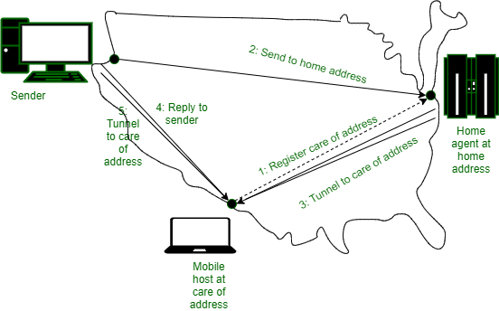

* When the encapsulated packet arrives at the care-of address, the mobile host unwraps it and retrieves the packet from the sender.
* The overall route is called triangle routing because it way is circuitous if the remote location is far from the home location.
* As part of the step, 4 senders learns the current care-of address.
* Subsequent packets can be routed directly to the mobile host by tunneling them to the care-of address (step 5) bypassing the home location.
* If connectivity lost for any reason as the mobile moves, the home address can always be used to reach the mobile.

<https://www.youtube.com/watch?v=IUbp0FMvdvA>

video lecture link

Channel Allocation Strategies in Computer Network

[Channel Allocation](https://www.geeksforgeeks.org/channel-allocation-problem-in-computer-network/) means to allocate the available channels to the cells in a cellular system. When a user wants to make a call request then by using channel allocation strategies their requests are fulfilled. Channel Allocation Strategies are designed in such a way that there is efficient use of frequencies, time slots and bandwidth.

**Types of Channel Allocation Strategies:**

These are Fixed, Dynamic, and Hybrid Channel Allocation as explained as following below.

* **Fixed Channel Allocation (FCA):**   
  Fixed Channel Allocation is a strategy in which fixed number of channels or voice channels are allocated to the cells. Once the channels are allocated to the specific cells then they cannot be changed. In FCA channels are allocated in a manner that maximize *Frequency reuse*.  
  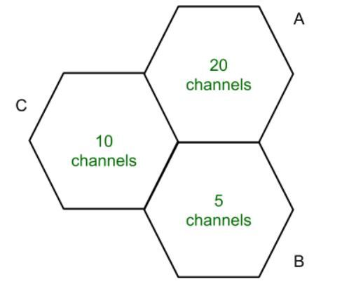   
  In cell A 20 Channels or Voice channels are allocated. If all channels are occupied and user make a call then the call is blocked. *Borrowing Channels* handles this type of problem. This cell borrow channels from other cells.
* **DynamicChannelAllocation (DCA):**   
  Dynamic Channel allocation is a strategy in which channels are not permanently allocated to the cells. When a User makes a call request then Base Station (BS) send that request to the Mobile Station Center (MSC) for the allocation of channels or voice channels. This way the likelihood of blocking calls is reduced. As traffic increases more channels are assigned and vice-versa.
* **Hybrid Channel Allocation (HCA):**   
  Hybrid Channel Allocation is a combination of both Fixed Channel Allocation (FCA) and Dynamic Channel Allocation (DCA). The total number of channels or voice channels are divided into fixed and dynamic set. When a user make a call then first fixed set of channels are utilized but if all the fixed sets are busy then dynamic sets are used. The main purpose of HCA is to work efficiently under heavy traffic and to maintain a minimum S/I.

Video lecture link

<https://www.youtube.com/watch?v=0iqaoQkdLa0>